

FAZAIA BILQUIS COLLEGE OF EDUCATION FOR WOMEN

NUR KHAN BASE

Data Structure Project

Submitted by:
- Fatima (25)
- Eesha saiq (45)
- Urooj Shehzadi (70)

Submitted to: Mam Ayesha Bashir

Title: Restaurant Management System

Date: 29-12-2024

1. Introduction
The Restaurant Management System (RMS) is a simple program created to help restaurants manage their daily operations. It allows admins to manage the menu, track sales, and undo actions. Customers can view the menu, place orders, and get their bills. The system was developed using C++ and works through a console interface, making it easy for restaurant staff and customers to use.

2. Functional Requirements
Admin Section:
- Admin Login: The admin can log in with the username (admin) and password (1234).
- View Total Sales: Admin can see a record of all sales, including item names, quantities, and total amounts.
- Add Items to the Menu: Admin can add new food items by entering the item’s serial number, name, and price.
- Delete Items from the Menu: Admin can remove items from the menu.
- View the Menu: Admin can see the full list of food items available for sale.
- Undo Last Action: Admin can undo the last change made to the menu (whether adding or deleting an item).
- Save Sales Data: All sales data is saved in a file with a timestamp, so it can be reviewed later.
- Search sales by date: User can search the sales on particular date.
- Search sales bt date and time: User can search the sales by time also.
Customer Section:
- View Menu: Customers can see the menu with food items and prices.
- Place Orders: Customers can select food items and specify how many they want to order.
- View Ordered Items: Customers can check the items they have added to their order before completing it.
- Delete Items from Order: Customers can remove items from their order if they change their mind.
- Get Final Bill: The system generates a bill showing all ordered items, their quantities, and the total amount.
- Search Sales by Date and Time: Admins and customers can search sales records by date and time.

3. Non-Functional Requirements
Performance:
- The system should work quickly and smoothly, even with up to 1,000 items or sales records.
- Requests like adding or removing items should be processed without delays.
Usability:
- The program is simple to use and has clear instructions for users.
- The system provides error messages when something goes wrong (e.g., invalid input).
Security:
- Only the admin can access special features like managing the menu and viewing sales records.
- Admin login is protected by a username and password. After three failed login attempts, the system locks the user out for 30 seconds.
Reliability:
- This system ensures that all data is saved correctly, even if changes are undone.
- If an error happens (like trying to delete an item that doesn’t exist), the system handles it without crashing.
Compatibility:
- This system works on Windows and is written in C++ using DevC++ IDE.

4. Design Overview
System Structure:
The RMS is divided into two main parts:
- Admin Section: Admin can manage the menu and view sales.
- Customer Section: Customers can view the menu, place orders, and get a bill.
Data Structures:
- Linked List: Used to store menu items and customer orders. Each item contains details like name, price, and quantity.
- Queue: Manages customer orders in the order they were placed.
- Stack: Stores actions for the admin, so they can undo their last change.
File Handling:
Sales data is saved in a text file with a timestamp. This file includes the details of items sold, quantities, and prices, which can be used for reporting.

5. Code Explanation

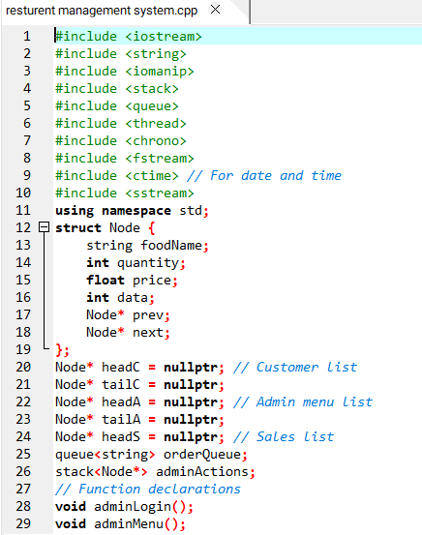

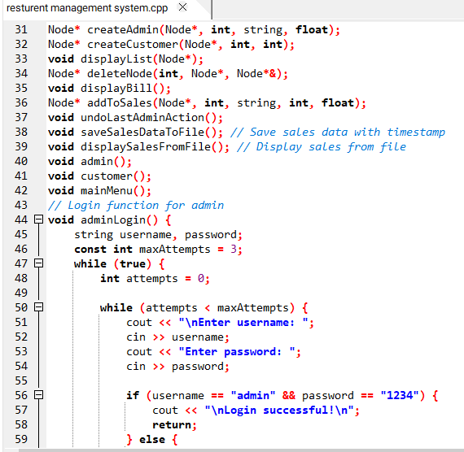

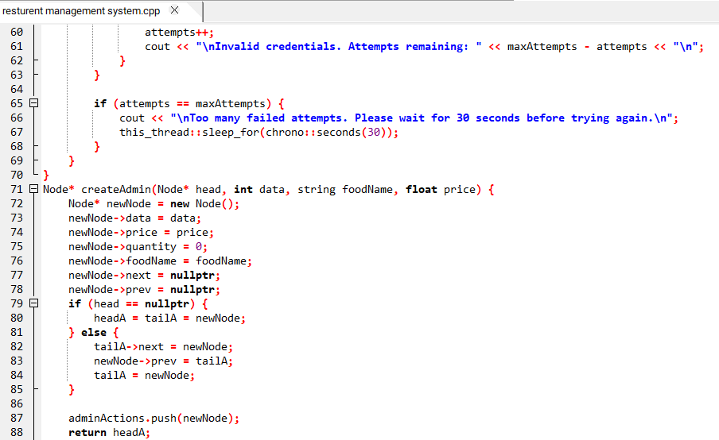
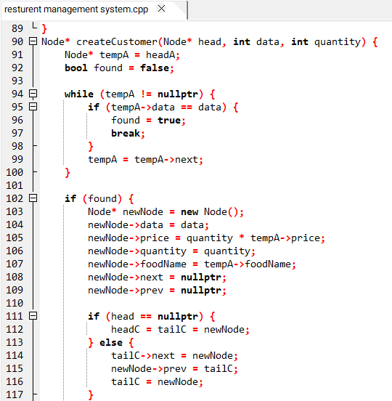
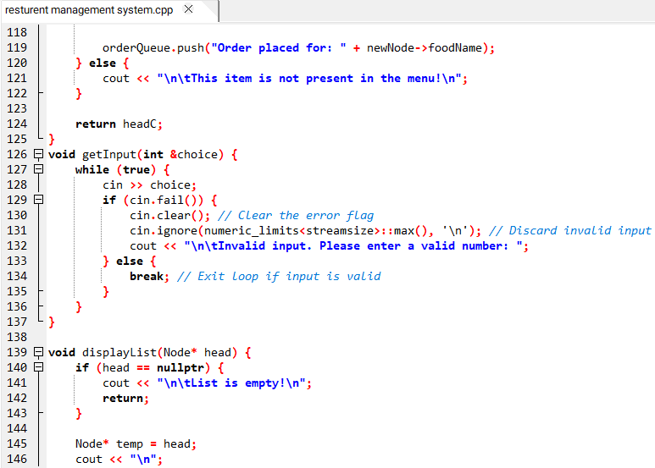
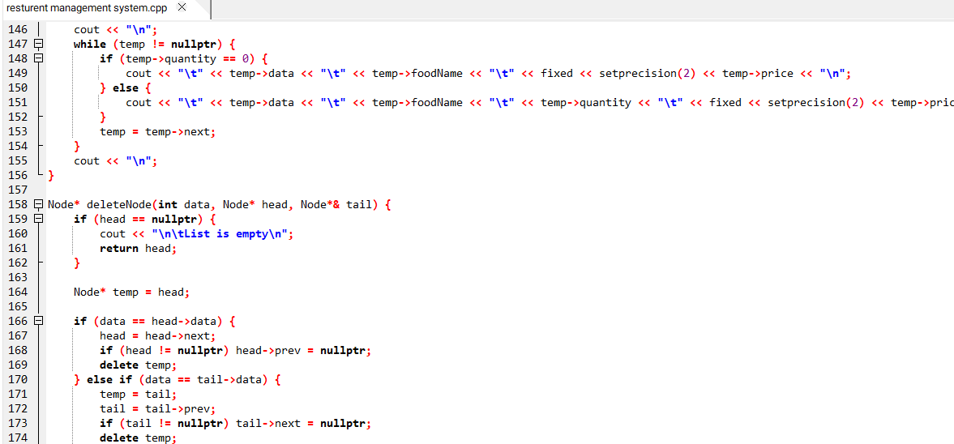
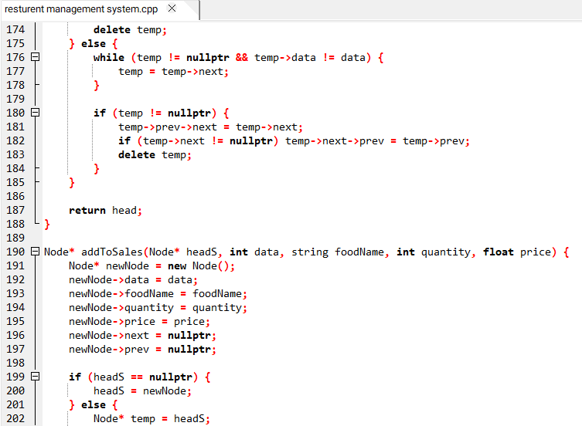

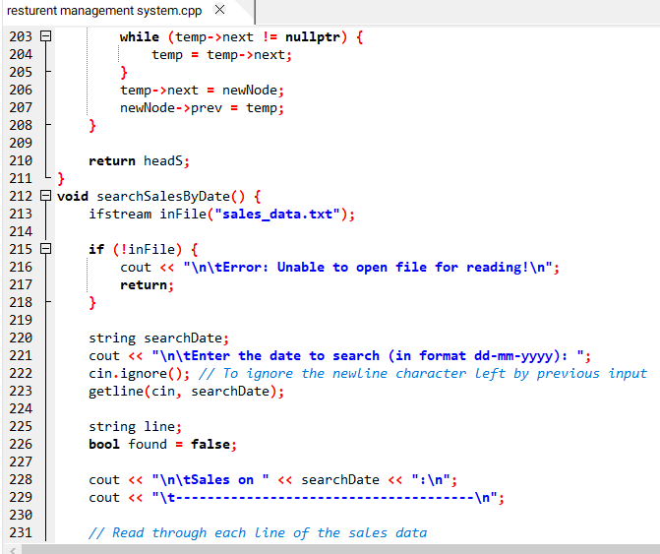

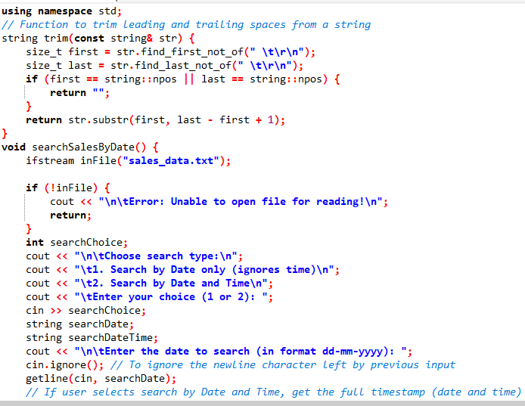

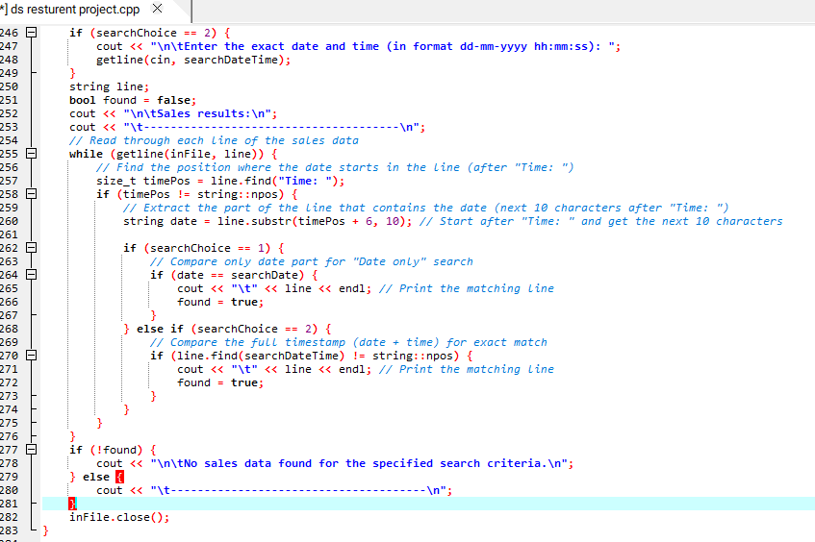

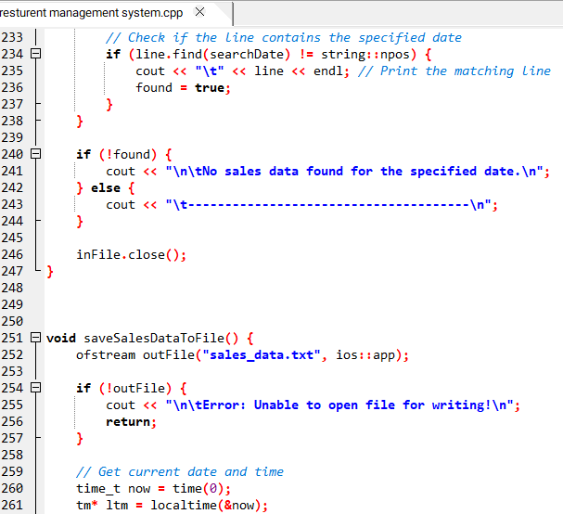
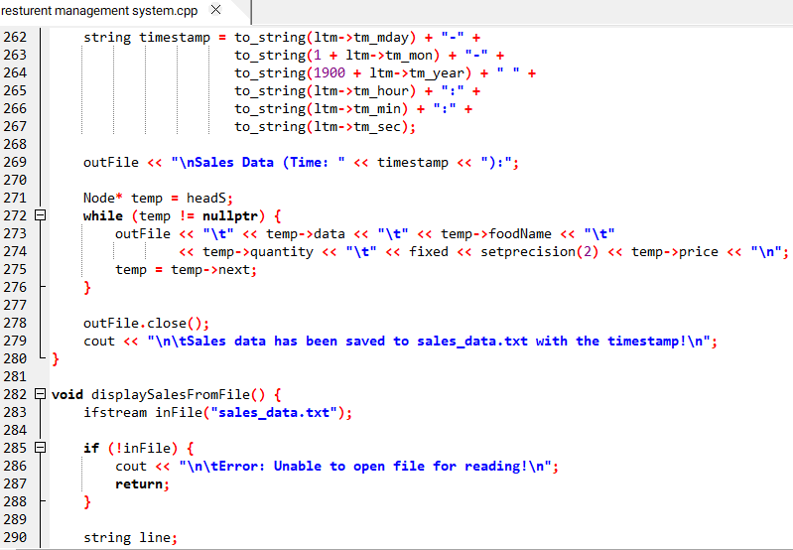
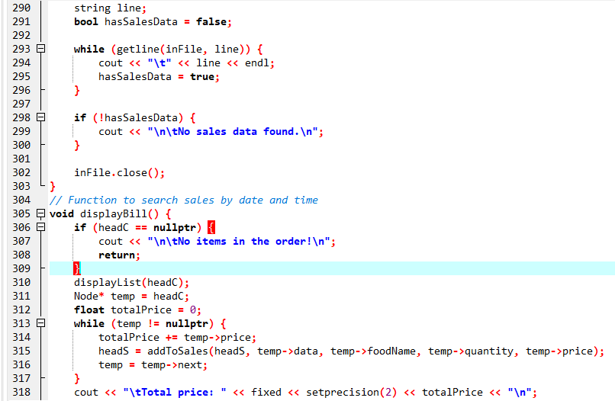
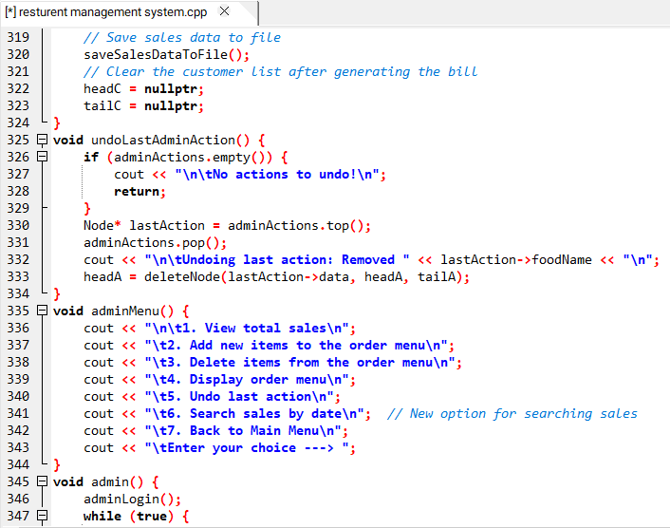
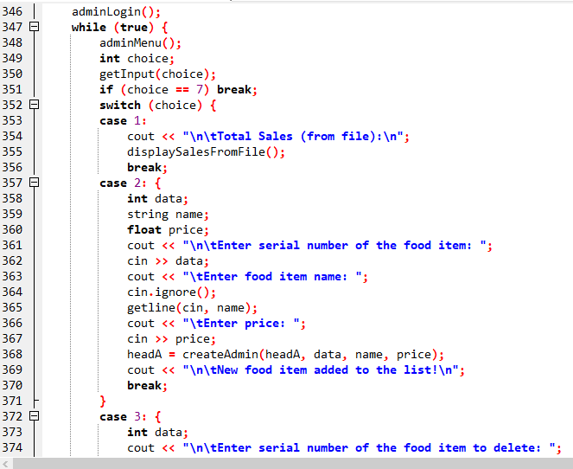
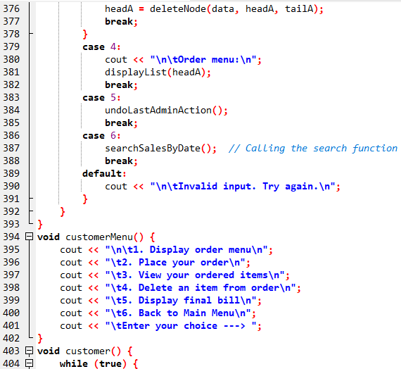
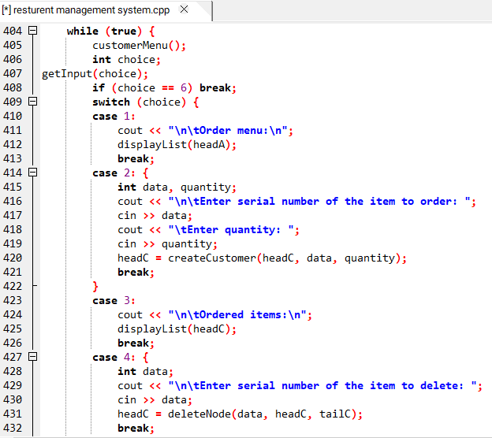
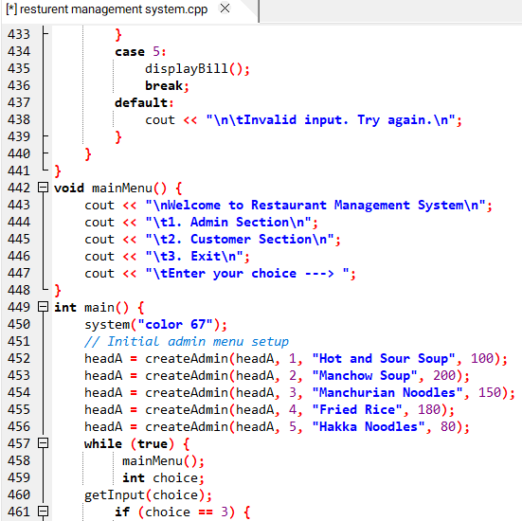
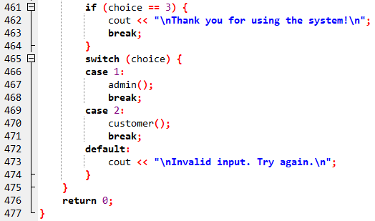

Output:

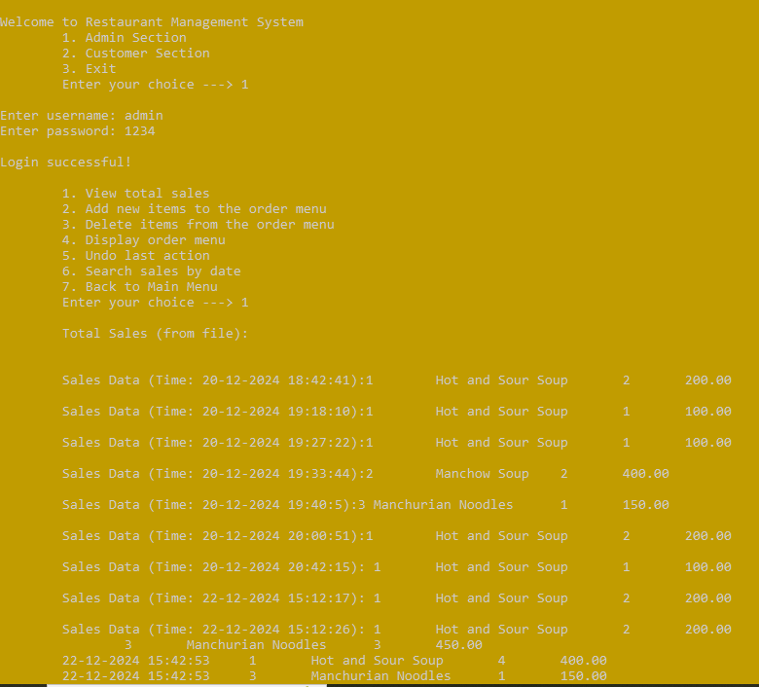
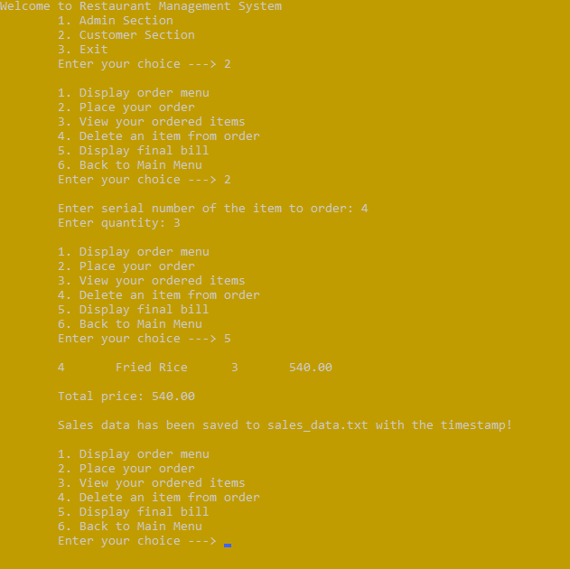

6. Testing
Test Cases:
- Admin Login Test: Check that the admin can log in with the correct credentials, and that the system locks after three failed attempts.
- Menu Management: Test adding and removing items from the menu.
- Customer Ordering: Test placing an order, viewing the order, removing items, and getting the final bill.
- Sales Data File: Test if the system correctly saves and loads sales data.
- Sales Search: Test the ability to search sales records by date and time.
Testing Results:
- All tests passed successfully, including login, menu management, order placement, and sales tracking.

7. Challenges and Limitations
Challenges:
- Undoing admin actions was tricky, especially when managing the linked list.
- Ensuring data is saved correctly after actions like deleting items required careful handling.
Limitations:
- The system only works in a console and doesn’t have a graphical interface (GUI).
- Searching by timestamp could become slow with very large amounts of data.

8. Conclusion
The Restaurant Management System works as intended, meeting the key requirements for managing a restaurant's menu, sales, and orders. The system is easy to use and reliable. Future improvements could include adding a graphical interface and making the search feature faster.
4o mini

